

**ENGINEERING FACULTY**

**COMPUTER ENGINEERING**

**BIM423**

**SOFTWARE ENGINEERING**

**FALL TERM**

**SEMESTER PROJECT**

**FINAL REPORT**

**Instructor:** Assoc. Prof. Dr. Özgür YILMAZEL

**Teaching Assistant:** Res. Asst Muhammet Yasin PAK

**Students:**

**20290758788** - Sıtkı Burak ÇALIM

**54520521262** - Oktay KIRIK

**30928274948** - Hakan YILDIZ

**29122110244** - Okan ÖZTABAN

**17849008388** - Serhat YAVAŞ

**TABLE OF CONTENTS**

1. **Introduction**

**1.1** Purpose of this document

**1.2** Intended Audience

**1.3** Document Scope

**1.4** Definitions and Ancronyms

**1.5** Project Team Intruduction

**1. INTRODUCTION**

**1.1 Purpose of This Document**

The purpose of this document is to provide all information about developing and creating process of the project TotoCafe by SOHOS Software Development Team for BIM423 – Software Engineering class.

**1.2 Intended Audience**

The intended audiences of this document's presentation are other project groups who attended BIM423 class, instructor Assoc. Prof. Dr. Özgür Yılmazel and teaching assistant Res. Asst. Muhammet Yasin Pak.

**1.3 Document Scope**

This document should provide information and presentation to intended audience about development development of TotoCafe project.

**1.4 Definitions and Acronyms**

**1.5 Project Team Introduction**

SOHOS Software Development Team was founded in February 2014 in Anadolu University Computer Engineering class-mates to make school works and homeworks at first. Than thanks to members started working in different areas, SOHOS became a team that is able to develop all different kinds of projects. SOHOS developed one game level design for European Union Living Lab, one web-site for Tepebaşı Youth Council so far and has 2 ongoing projects.

**2. PROJECT SCOPE**

**2.1 Toto Cafe**

Toto Cafe is a mobile project that aims to make ordering and paying easier in cafes, restaurants and pubs. Program will be made of mobile application for customer, web-page for administrator and server on

cloud for the database and communication between customer and administrator.

Customer will enter the restaurant and show the QR code to the application. Registered administrator will see the table request and confirm and the table will become occupied in the system. Customer will get the menu and Wi-Fi password. Orders will be taken by mobile. At the end, payment details will be seen by customer on phone and owner of the place by web-page.

**2.2 Project scope statement**

Our main objective is reduce human mistakes to the minimum. For this process, our work will provide minimum order delay, accurate delivery and insure minimum disagreement on cheque. Web and mobile interfaces will provide easy and fast control for ordering process. Toto Cafe's difference from similar applications will be special offers from places to regular customers. Other than that users will be able to see their historical statistics in this application. Lastly we aimed to reduce over usage of paper menus.

**2.3 Introduction / Background to project**

In a big or busy place customer can be obliged to

wait a long time for an order process. Due to this problem we want to reduce delay time of orders and miscommunication between customer and place.

**2.4 Business case**

Our product’s aim is to reduce human mistakes for places. What our project provide is fast and secure system for service-based places. Other than that our project store historical statistics so administrators can decide forward planning easily.

**2.5 Deliverables**

In the end of the project we will deliver:

Administration webpage

Android application for users

Database service for places and users which is encrypted with SHA1.

**2.6 In scope**

We will provide maintenance service and a webpage for places to organize their menus, order queue and table conditions. Our mobile application will provide faster and accurate orders for users. With our database users and places can check their historical statistics.

**2.7 Out of scope**

Only project expense will be cost of Azure account for release. For now, we will make the project on free trial for Azure. Besides, project will be open source and will not take any payment.

# 3. ORGANIZATION

## Project Manager

Oktay Kırık

## Project Group

|  |  |
| --- | --- |
| NAME | RESPONSIBILITY |
| Sıtkı Burak Çalım | ASP.NET |
| Oktay Kırık | Database, ASP.NET, Web Services |
| Hakan Yıldız | Android |
| Okan Öztaban | Android |
| Serhat Yavaş | UI Design |

## Steering Group

Hakan Yıldız

## Customer

Özgür Yılmazel, Muhammet Yasin Pak

# 4.USE CASES FOR TOTOCAFE

## 4.1 Brief Description

This use case describes how users use the TotoCafe application to order from their mobile devices.

## Actors

* Client
* Administrator

## 4.3 Preconditions

Client has a mobile device which connected to Internet and running TotoCafe application on Android. The device must also have a camera to read QR codes on the tables.

Administrator has a device that connected to Internet and supports TotoCafe Web Application.



## 4.4 Basic Flow of Events for Use Cases

### 4.4.1 Login

Admin Login: Administrator visits TotoCafe Web Application and enters login informations. After successfully login Administrator sees main page of TotoCafe Web Application and asked to arrange tables and menu information.

Client Login: Client opens TotoCafe Android Application and enters login informations. After successfully login Client asked to open camera on device to read the QR code on the table.

### 4.4.2 Arrange Tables and Menu

Administrator navigates to settings page and enter table and menu informations that belong to company. Downloads generated QR codes for tables and stick them onto each table.

### 4.4.3 Table Request

Client opens camera on TotoCafe Android Application and reads the QR code on the table. After reading QR code a request will be sent to company programatically. Client waits until Administrator’s confirmation.

When Administrator gets the request from the Client, Administrator has two options for confirmation:

* Confirm
* Decline

If Administrator confirms the request Client will be able to see menu and order, otherwise will not.

### 4.4.4. Order

Client whom request confirmed can see menu. Client choses a package of product to order and send it to Administrator.

On the Administrator side ordering can be done in traditional way so Administrator has an authority on ordering too.

### 4.4.5 Payment

At the end, client goes to cash, pays the bill and after Administrator accepts the payment table will be closed automatically.

## 4.5 Post Conditions

### 4.5.1 Successful Conditions for Administrator

* Successful login to the system
* Arrange tables and menu settings
* Get order from client or add order in traditional way
* Accept payment and close table

### 4.5.2 Successful Conditions for Client

* Successful login to the system
* Open camera and read QR code
* Get confirmation from administrator
* View menu and select products to order
* Send order to Administrator
* Go to cash for payment

### 4.5.3 Unsuccessful Conditions

If the connection -between server and any side – drops becouse of any reason all processes will have to be processed in traditional way until the connection problem fixed

## 4.6 Alternative Solutions

If Client has no supporting device, Administrator side allows traditional ordering.

**5. SCHEDULING**

**5.1 Schedule Listing**

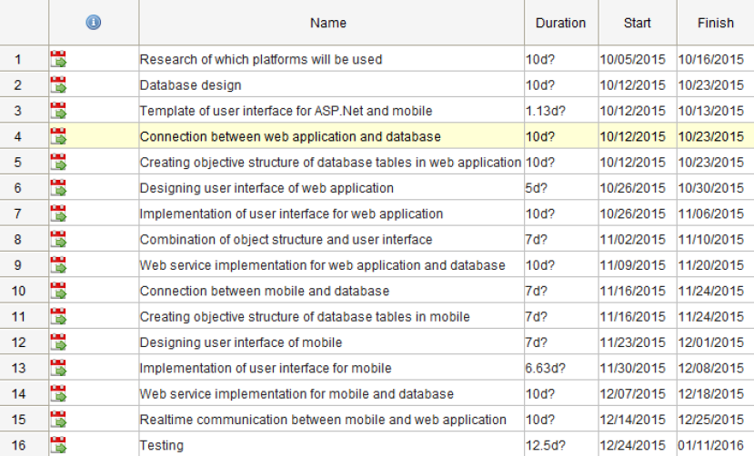

**5.2 Schedule Diagram**

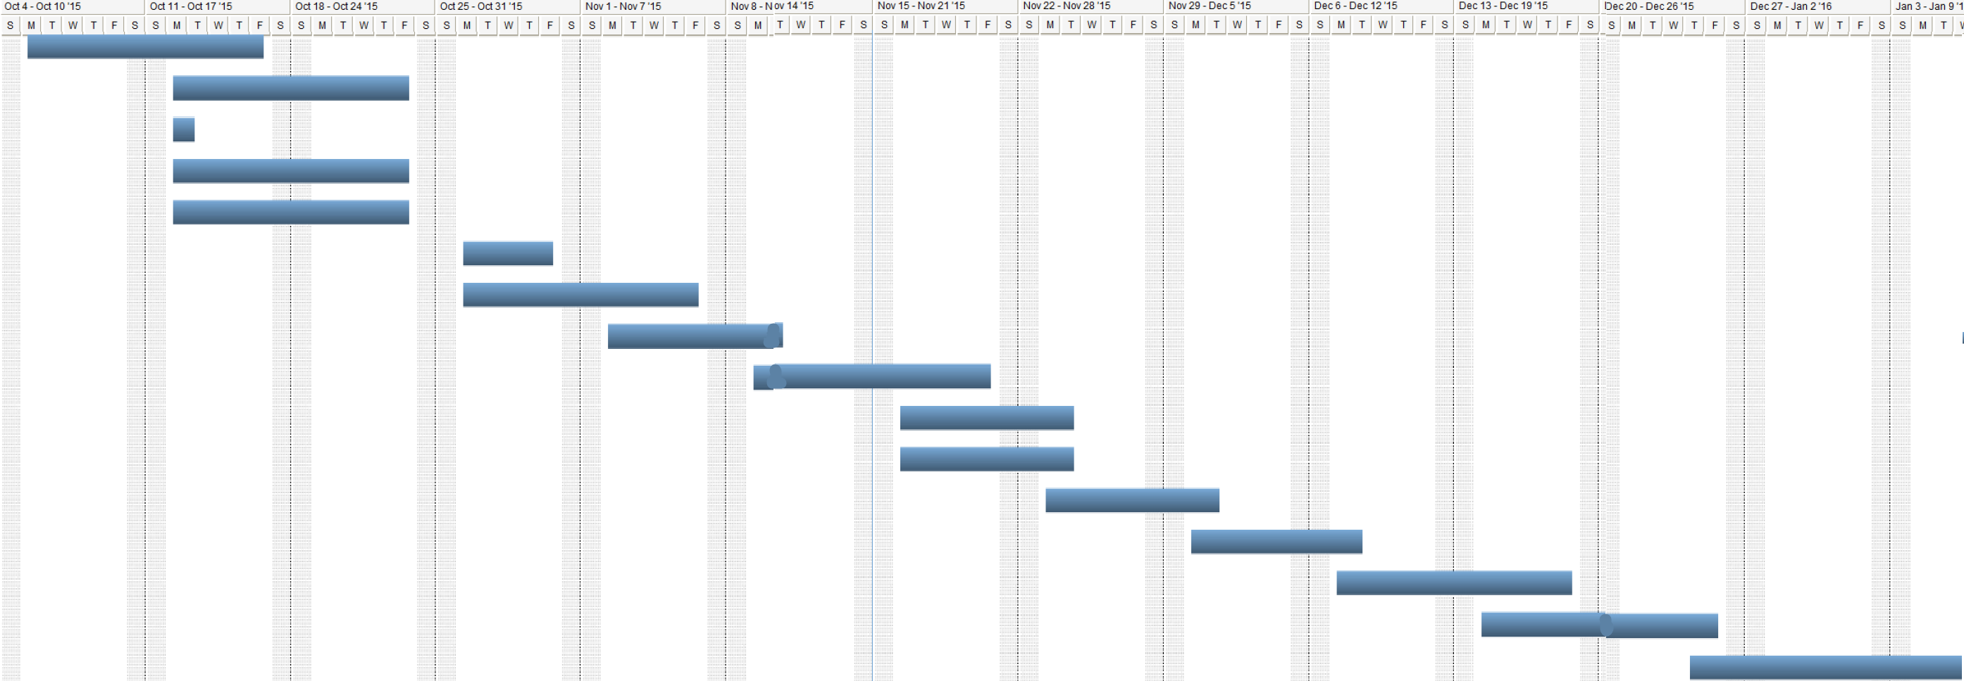

**6. PROJECT RESULTS**

|  |  |  |
| --- | --- | --- |
| **ID** | **Requirement Description** | **Completed** |
| **REQ-001** | Research of which platform will be used |  |
| **REQ-002** | Database Design |  |
| **REQ-003** | Template of user interface for ASP.NET and mobile |  |
| **REQ-004** | Connection between web application and database |  |
| **REQ-005** | Creating objective structure database tables in web application |  |
| **REQ-006** | Designing user interface of web application |  |
| **REQ-007** | Implementation of user interface of web application |  |
| **REQ-008** | Combination of object structure and user interface |  |
| **REQ-009** | Web service implementation for web application and database |  |
| **REQ-010** | Connection between mobile and database |  |
| **REQ-011** | Creating objective structure of database tables in mobile |  |
| **REQ-012** | Designing user interface for mobile |  |
| **REQ-013** | Implementation of user interface for mobile |  |
| **REQ-014** | Web services implementation for mobile and database |  |
| **REQ-015** | Realtime communication between mobile and web application |  |
| **REQ-016** | Testing |  |